BL-K1 Brushless DC Controller (DC24) User Manual
-  Precautions
- The 0V (negative pole) of the driver card power supply is grounded
- Before powering on, please make sure the positive and negative poles of the driver card power supply are connected correctly.
- Do not use in explosive environments, flammable gas environments, corrosive environments, places exposed to water, or near flammable materials.
- Do not touch the connection terminals of the driver card immediately after turning off the power (within 30 seconds), as residual voltage may cause electric shock.
- When setting up, connecting, running, operating, checking, and troubleshooting, all operations must be performed by qualified personnel.
- Please do not move, set up, connect, check, etc. when the power is on. When operating, be sure to cut off the power before operating.
Environmental requirements: Indoor (no direct sunlight, rain, water droplets, condensation and corrosive gas))
Usage Environment
Main Features
- Constant speed, start and stop, forward and reverse
- Analog speed regulation and IO control
- Acceleration/deceleration time adjustment
- Overvoltage/undervoltage/overcurrent protection
- Multiple LED alarm indicators
Operating ambient temperature | -10-40℃
Operating environment humidity | 10%-90%RH (no frost)

Electrical parameters
 | Numerical | default value | unit
Current | < 6 | 5 | A
Pole pairs | --- | 4 | ---
Acceleration and deceleration | 10-3000 | 50 | ms
Applicable speed | --- | 3000 | RPM
Dimensions
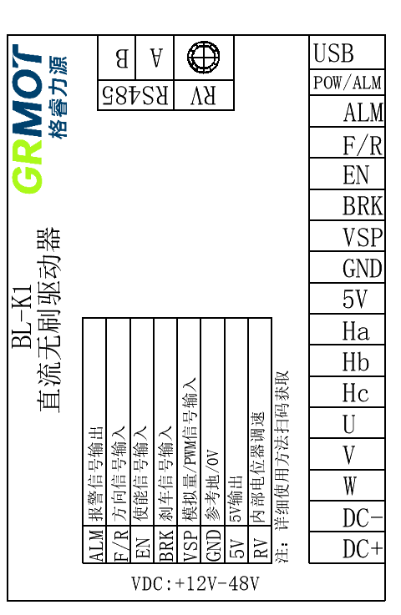

Interface Function
Features and functions |  |  | 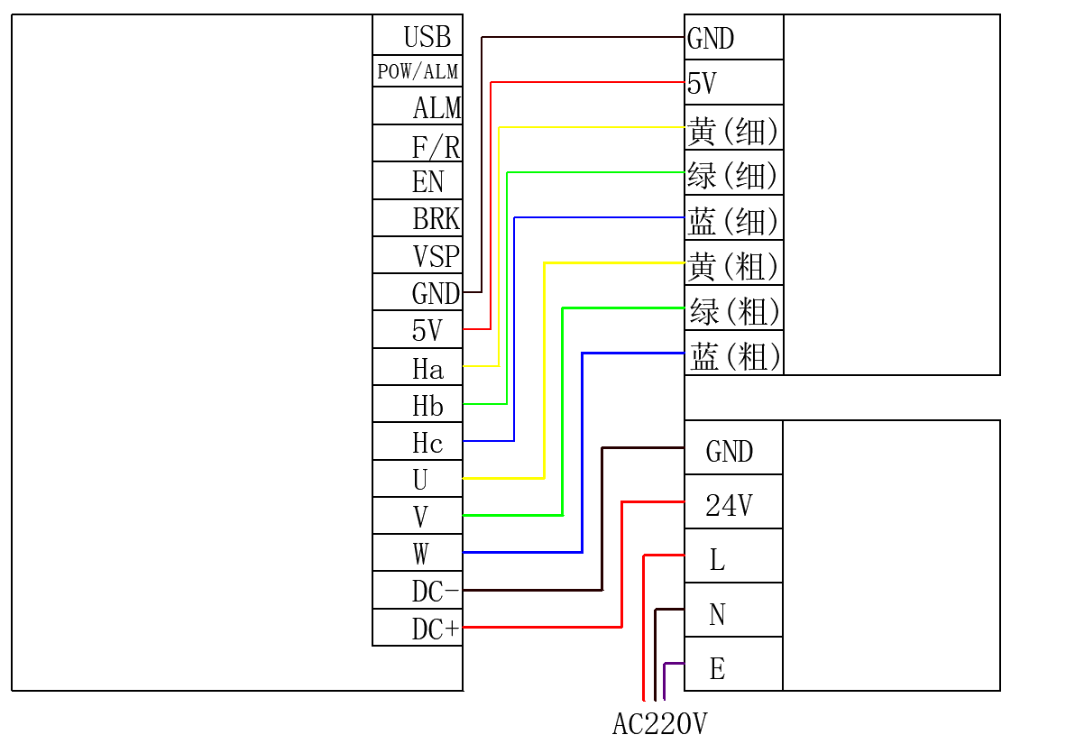Remark
powered by | Voltage | Normal operating voltage 24V±5%
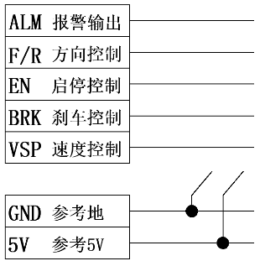 |  | - Start and stop control: connect 5V or disconnect to control running or stopping  - Direction control: connect 5V or disconnect to control forward or reverse  - Speed ​​control: When RV rotates counterclockwise ≤5%, VSP control is effective  When RV rotates clockwise ≥5%, RV control is effective  - Status indication: Controller abnormal ALM alarm 5V output  The indicator lights flash alternately (see the attached table for details)

Wiring Diagram

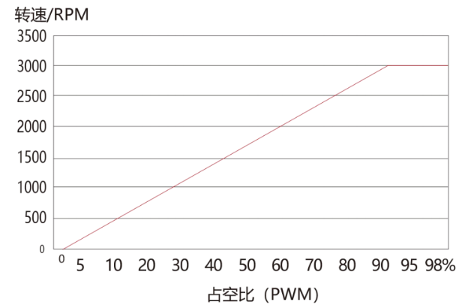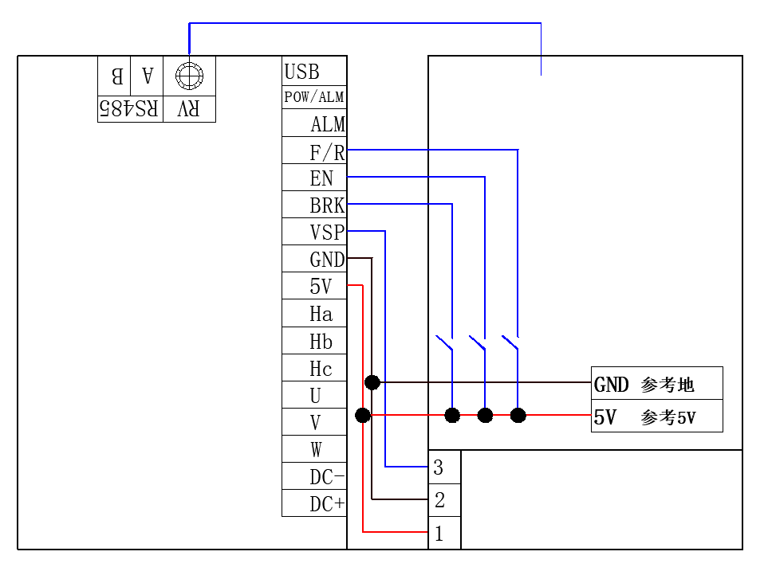Function/mode diagram

Use external analog speed control DC (0~5V)
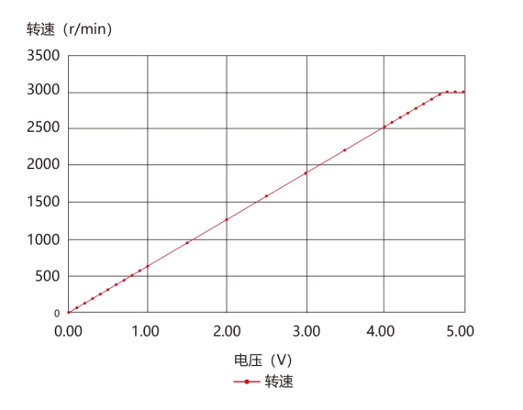
When switching to external analog speed control mode, the built-in potentiometer RV must be in the off state. This means turning the built-in potentiometer RV counterclockwise to the <5% limit. The factory default maximum speed of the drive is 3000 rpm. To change this default, please contact us.
The right picture is the curve of a certain external analog speed regulation linearity test
When switching to external analog speed control mode, the built-in potentiometer RV must be in the off state. This means turning the built-in potentiometer RV counterclockwise to the <5% limit. The factory default maximum speed of the drive is 3000 rpm. To change this default, please contact us.
The right picture is the curve of a certain external analog speed regulation linearity test
When switching to external analog speed control mode, the built-in potentiometer RV must be in the off state. This means turning the built-in potentiometer RV counterclockwise to the <5% limit. The factory default maximum speed of the drive is 3000 rpm. To change this default, please contact us.
The right picture is the curve of a certain external analog speed regulation linearity test
When switching to external analog speed control mode, the built-in potentiometer RV must be in the off state. This means turning the built-in potentiometer RV counterclockwise to the <5% limit. The factory default maximum speed of the drive is 3000 rpm. To change this default, please contact us.
The right picture is the curve of a certain external analog speed regulation linearity test
Use PWM speed control
PWM speed control input, with a duty cycle ranging from 2% to 95% for speed control. When the duty cycle is greater than 95%, the motor speed reaches its maximum value. The maximum speed value depends on the motor specifications and power supply voltage (duty cycle pulse frequency range: 10-50kHz, waveform: pulse wave, amplitude: 0-5V, note: high level 2.2V-5V, low level 0-0.7V). Note: Only supports PLCs with a signal voltage of 5V.

Status indicator and abnormal handling
1 green 4 red | Driver voltage is too high | The power supply voltage is too high
1 green 5 red | Driver overcurrent | Motor wiring error or MOS short circuit
1 green 6 red | Motor open circuit | The motor power line is not connected properly
2 green 3 red | Internal voltage error | Driver internal circuit failure
2 green 4 red | Driver voltage is too low | The supply voltage is lower than 15VDC
2 green 5 red | Motor overload | External load is too large
2 green 6 red | Hall signal error | Hall signal line is not connected properly
1 green 7 red | Communication Error | The communication line is not connected properly
2 green 7 red | FLASH read/write errors

